**Apache Airflow – Coding Assessment (20-08-2025)**

**Building a Simple Data Pipeline**

Create a Postgres Connection

Before our pipeline can write to Postgres, we need to tell Airflow how to connect to it. In the UI, open the **Admin > Connections** page and click the + button to add a new connection.

Fill in the following details:

* Connection ID: tutorial_pg_conn
* Connection Type: Postgres
* Host: postgres
* Database: airflow (this is the default database in our container)
* Login: airflow
* Password: airflow
* Port: 5432

Save the connection. This tells Airflow how to reach the Postgres database running in your Docker environment.

Next, we’ll start building the pipeline that uses this connection.

**Create tables for staging and final data**

Let’s begin with table creation. We’ll create two tables:

* employees_temp: a staging table used for raw data
* employees: the cleaned and deduplicated destination

We’ll use the SQLExecuteQueryOperator to run the SQL statements needed to create these tables.

You have to save the code in the ‘materials’ location under dags and name it as process_employees.py.

**CODE:**

from airflow import DAG

from airflow.providers.sqlite.operators.sqlite import SqliteOperator

from datetime import datetime

with DAG(

dag_id="process_employees_dag",

start_date=datetime(2023, 1, 1),

schedule_interval=None,

catchup=False,

) as dag:

create_employees_table = SqliteOperator(

task_id="create_employees_table",

sqlite_conn_id="my_sqlite_conn",

sql="""

CREATE TABLE IF NOT EXISTS employees (

id INTEGER PRIMARY KEY,

name TEXT,

department TEXT

)

""",

)

create_employees_temp_table = SqliteOperator(

task_id="create_employees_temp_table",

sqlite_conn_id="my_sqlite_conn",

sql="""

CREATE TABLE IF NOT EXISTS employees_temp (

id INTEGER,

name TEXT,

department TEXT

)

""",

)

create_employees_table >> create_employees_temp_table

After this step you will see the process_employees dag name in the DAGs

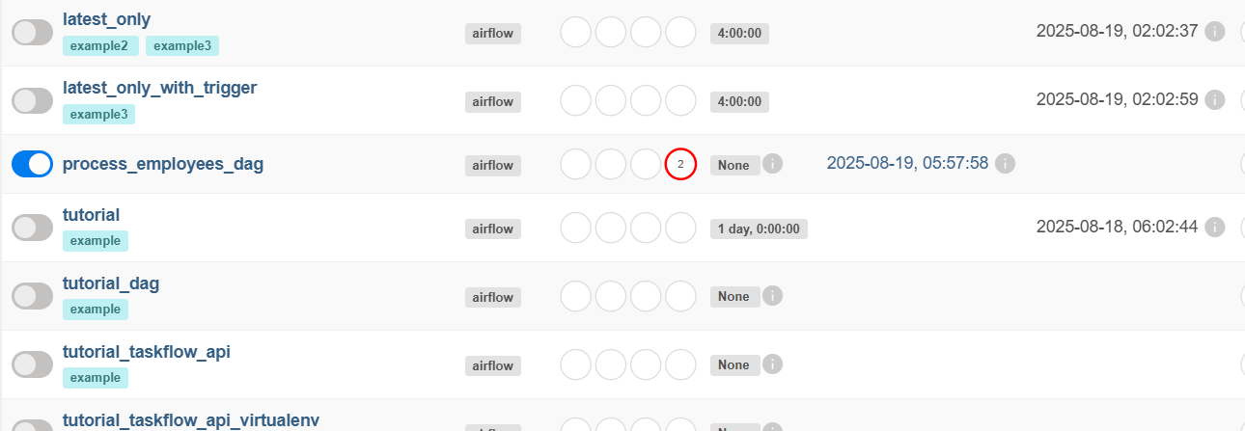

**Load data into the staging table**

Next, we’ll download a CSV file, save it locally, and load it into employees_temp using the PostgresHook.

**Then modify the code in process_employees.py like below for Loading data:**

from datetime import datetime

from airflow import DAG

from airflow.providers.postgres.operators.postgres import PostgresOperator

from airflow.decorators import task

from airflow.providers.postgres.hooks.postgres import PostgresHook

import os

import requests

# Task to download CSV and load into Postgres

@task

def get_data():

    data_path = "/opt/airflow/dags/files/employees.csv"

    os.makedirs(os.path.dirname(data_path), exist_ok=True)

    # Download CSV

    url = "https://raw.githubusercontent.com/apache/airflow/main/airflow-core/docs/tutorial/pipeline_example.csv"

    response = requests.get(url)

    with open(data_path, "w", encoding="utf-8") as file:

        file.write(response.text)

    # Load into Postgres

    postgres_hook = PostgresHook(postgres_conn_id="tutorial_pg_conn")

    conn = postgres_hook.get_conn()

    cur = conn.cursor()

    with open(data_path, "r", encoding="utf-8") as file:

        cur.copy_expert("""

            COPY employees_temp FROM STDIN WITH CSV HEADER

            DELIMITER ',' QUOTE '"'

        """, file)

    conn.commit()

    cur.close()

    conn.close()

with DAG(

    dag_id="process_employees_dag",

    start_date=datetime(2023, 1, 1),

    schedule_interval=None,

    catchup=False,

) as dag:

    # Create employees main table

    create_employees_table = PostgresOperator(

        task_id="create_employees_table",

        postgres_conn_id="tutorial_pg_conn",

        sql="""

        CREATE TABLE IF NOT EXISTS employees (

            id INTEGER PRIMARY KEY,

            name TEXT,

            department TEXT

        )

        """,

    )

    # Create employees temp table

    create_employees_temp_table = PostgresOperator(

        task_id="create_employees_temp_table",

        postgres_conn_id="tutorial_pg_conn",

        sql="""

        CREATE TABLE IF NOT EXISTS employees_temp (

            id INTEGER,

            name TEXT,

            department TEXT

        )

        """,

    )

    # Run tasks in sequence

    create_employees_table >> create_employees_temp_table >> get_data()

Then trigger the dag again to see the updation done via code .

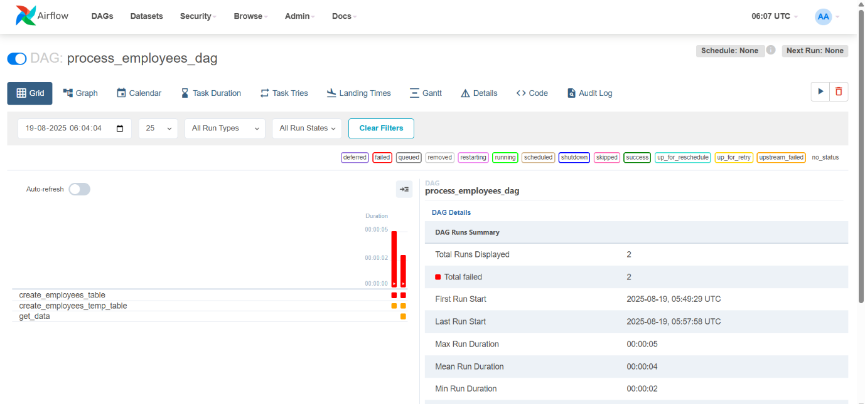

Now create an employees.csv file in the location ~/materials/dags/data/employees.csv

**Merge and clean the data**

Now let’s deduplicate the data and merge it into our final table. We’ll write a task that runs a SQL *INSERT … ON CONFLICT DO UPDATE*.

Modify the code in process_employees.py file like below:

from datetime import datetime

from airflow import DAG

from airflow.providers.postgres.operators.postgres import PostgresOperator

from airflow.decorators import task

from airflow.providers.postgres.hooks.postgres import PostgresHook

import os

# Task to load CSV into Postgres

@task

def get_data():

    data_path = "/opt/airflow/dags/employees.csv"

    if not os.path.exists(data_path):

        raise FileNotFoundError(f"{data_path} not found. Please place employees.csv there.")

    # Load into Postgres

    postgres_hook = PostgresHook(postgres_conn_id="tutorial_pg_conn")

    conn = postgres_hook.get_conn()

    cur = conn.cursor()

    with open(data_path, "r", encoding="utf-8") as file:

        cur.copy_expert("""

            COPY employees_temp FROM STDIN WITH CSV HEADER

            DELIMITER ',' QUOTE '"'

        """, file)

    conn.commit()

    cur.close()

    conn.close()

with DAG(

    dag_id="process_employees_dag",

    start_date=datetime(2023, 1, 1),

    schedule_interval=None,

    catchup=False,

) as dag:

    # Create employees main table

    create_employees_table = PostgresOperator(

        task_id="create_employees_table",

        postgres_conn_id="tutorial_pg_conn",

        sql="""

        CREATE TABLE IF NOT EXISTS employees (

            id INTEGER PRIMARY KEY,

            name TEXT,

            department TEXT

        )

        """,

    )

    # Create employees temp table

    create_employees_temp_table = PostgresOperator(

        task_id="create_employees_temp_table",

        postgres_conn_id="tutorial_pg_conn",

        sql="""

        CREATE TABLE IF NOT EXISTS employees_temp (

            id INTEGER,

            name TEXT,

            department TEXT

        )

        """,

    )

    # Merge data from temp into main table

    merge_data = PostgresOperator(

        task_id="merge_data",

        postgres_conn_id="tutorial_pg_conn",

        sql="""

        INSERT INTO employees (id, name, department)

        SELECT DISTINCT id, name, department

        FROM employees_temp

        ON CONFLICT (id) DO UPDATE

        SET

            name = EXCLUDED.name,

            department = EXCLUDED.department;

        """,

    )

    # Run tasks in sequence

    create_employees_table >> create_employees_temp_table >> get_data() >> merge_data

